# Falco Slack Notifications

Go to <https://api.slack.com/apps>

Select incoming webhooks

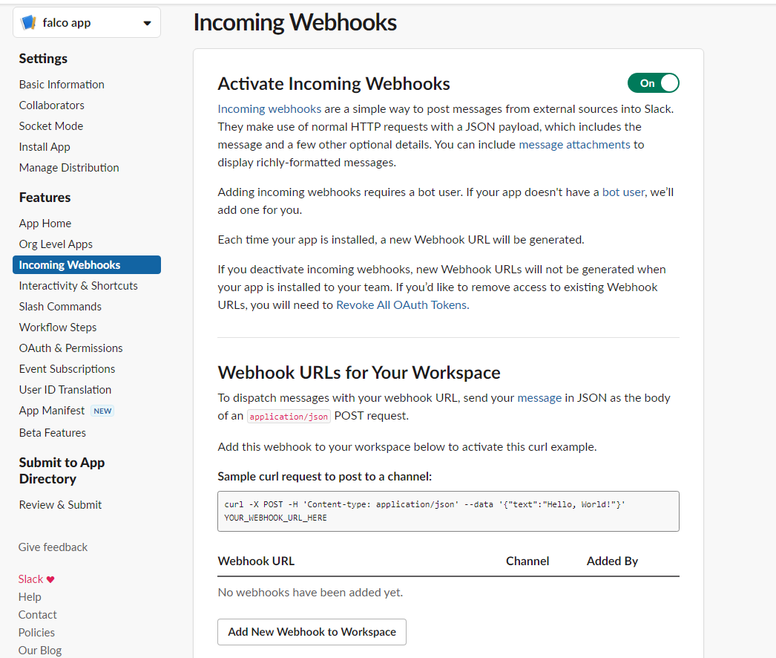

Select add new webhook to workspace

falco app is requesting permission to access the 
devsecops Slack workspace 
Where should falco app post? 
# falco app requires a channel to post to as an app 
# falco 
Cancel 
Allow 

Select channel and allow

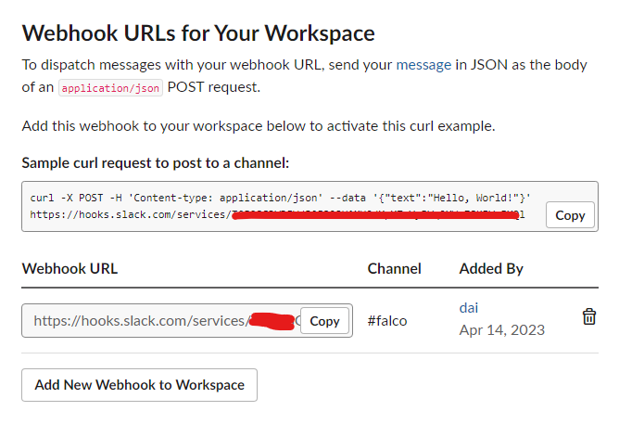

We can copy sample curl to test connection and update webhook-url into falco.

|  |
| --- |
| helm upgrade falco falcosecurity/falco \  --set falcosidekick.enabled=true \  --set falcosidekick.webui.enabled=true \  --set falcosidekick.config.slack.webhookurl="https://hooks.slack.com/services/<ID>" \  -n falco |

Execute shell nginx to test notification:

|  |
| --- |
| kubectl exec -it nginx -- sh |

